

**REVOLUTIONIZING FINANCIAL DECISION-MAKING**

Development Of an Intelligent Stock Trader Platform

**MACHINE LEARNING**

Module Name : Machine Learning

Module Code : BCC628

Student Name : Mathumitha Kamalanathan

student id( Solent id) : 102162598

# ACKNOWLEDGEMENT

I sincerely thank everyone who has been a part of this fulfillment. The commitment and insight of my lecturer Miss Nixsala Nadesan have served as a beacon of guidance, while the friendship and mutual learning among my classmates have greatly enhanced the experience. To successfully navigate the complexity of this project, having access to state-of-the-art information and technologies that were customized to my needs was essential. This network of mutual support not only helped accomplish the goals but also promoted a better comprehension and enjoyment of the subject of study.

Thank You.

Mathumitha Kamalanathan

Solent ID: 102162598

**CONTENTS**

ACKNOWLEDGEMENT 1

INTRODUCTION 4

OVERVIEW 4

BACKGROUND 5

DATA COLLECTION 5

PREPROCESSING 6

MODEL SELECTION AND DEVELOPMENT 8

SYSTEM DESIGN AND USER INTERFACE 11

DATA VISUALIZATION 21

DATA QUALITY CHECK 22

INSTALL REQUIRED LIBRARIES 22

APPLICATION OF MACHINE LEARNING PRINCIPLES 23

EVALUATION AND RESULTS 24

CHALLENGES AND SOLUTIONS 25

ETHICAL AND RULES 27

APPENDICES 27

SELECTING A FRAMEWORK FOR BACKEND DEVELOPMENT IN JAVASCRIPT AJAX. 28

CONCLUSION 30

REFERENCES 31

**FIGURE TABLE**

Figure 1 Interface of Yahoo Finance 6

Figure 2 Install yfinance 7

Figure 3 Linear stock prediction code 8

Figure 4 store prices input code 8

Figure 5 Stock prediction using linear regression for msn 10

Figure 6 Stock prediction using linear regression for AAPL 11

Figure 7 Login page code 12

Figure 8 CSS code in login page 13

Figure 9 using script and chart.js 14

Figure 10 JavaScript using in stock prediction chart 15

Figure 11 using async function in stock charts making 15

Figure 12 Fetch data 16

Figure 13 User Login Page 17

Figure 14 Login Error 17

Figure 15 AAPL stock chart 18

Figure 16 Different APIs Select in dropdown 20

Figure 17 Two APIs comparison 21

# **INTRODUCTION**

Solent Financial Technology (SOLFINTECH), a major participant in the financial sector, oversees a huge online investing platform that serves more than 50 million users and manages assets valued at more than 150 billion pounds. SOLFINTECH is at the vanguard of financial innovation and security, operating in the dynamic worlds of stocks, shares, and numerous investment routes across major stock exchanges such as the FTSE 100. With the launch of its Intelligent Stock Trader (IST) platform, SOLFINTECH is set to transform the trading industry at a time of both fast technical progress and growing competition from fintech startups. This state-of-the-art project attempts to capitalize on market fluctuations by predicting price movements with unprecedented accuracy over a variety of timeframes, ensuring maximum profitability and solidifying SOLFINTECH's market dominance. It does this by using sophisticated algorithms for astute stock buying and selling.

The subsequent parts of this article provide a study of the subtleties involved in creating an IST prototype system that aligns with SOLFINTECH's lofty objectives. This journey through technical know-how and strategic acumen unveils the fundamental components that allow the IST platform to evaluate intricate market behaviors, identify hidden patterns, and make trading simple. The technological breakthrough at the core of the IST system and its profound impact on modern financial settings are highlighted throughout this tale.

# **OVERVIEW**

I'm working on an innovative online application that will transform stock market forecasting. With its user-friendly interface, this platform will offer projections for 20 different firm stocks for the whole year, seamlessly combining the anticipated and actual closing prices to present a complete financial picture. A highly dynamic, user-friendly interface that is equipped with strong sign-in and registration tools to guarantee safe user access is at the heart of this design. The foundation of the program is HTML, which is augmented with Chart.js to provide dynamic, interactive charting features that make stock data interesting and easy to use. With the help of Bootstrap, a design is guaranteed to be both aesthetically pleasing and responsive, resulting in a flawless experience on a variety of devices. Activating real-time chart updates from an external API, the interface features a primary content section with a dropdown menu for stock selection and a simplified navigation bar. The Yahoo Finance API's enhanced core architecture holds great potential for future stock price forecasting capabilities, which will greatly increase the platform's value for financially astute customers.

# **BACKGROUND**

In the face of burgeoning competition from emergent fintech entities and a vast clientele, SOLFINTECH is set to unveil its Intelligent Stock Trader (IST) platform. This innovative platform is engineered to revolutionize trading strategies by leveraging intelligent algorithms to buy stocks from FTSE-listed companies at lower prices and sell them at a premium. Furthermore, it boasts predictive capabilities, forecasting stock and equity price movements on daily, weekly, monthly, and quarterly intervals, thereby identifying lucrative buy-low and sell-high opportunities.

The development of the IST platform is entrusted to a cadre of machine learning specialists, including your expertise. The team's mandate encompasses the meticulous processes of data acquisition and purification, crafting sophisticated machine learning algorithms, and architecting an intuitive user interface. Anticipated to be an indispensable asset for SOLFINTECH's clientele, the IST platform aims to empower investors with data-driven insights for sagacious investment choices.

The project, however, is not without its hurdles. Key challenges encompass the procurement and refinement of comprehensive historical stock price datasets, which are often marred by gaps or inaccuracies. The complexity of the stock market, influenced by myriad factors, presents a formidable challenge in the creation of precise predictive models. Additionally, the necessity of a user-centric interface design cannot be overstated, ensuring accessibility for a diverse user base, including those less versed in machine learning technologies.

# **DATA COLLECTION**

The quality of the supplied data is the cornerstone of developing an advanced Intelligent Stock Trader platform. I used the Yfinance library, a priceless resource for obtaining comprehensive stock market data, to guarantee the accuracy of our model. A variety of corporations, including "AAPL", "MSFT", "GOOGL", "LULU", "TM", "TSLA", "NVDA", "RBLX", "AMZN", "FB", "NFLX", "INTC", "IBM", "PYPL", "JPM", "DIS", "CSCO", "BA", "GE", and "KO". It makes their historical data easier to get thanks to this collection. To guarantee accuracy and relevance, I used a scientific approach to data collection, concentrating on picking accurate tickers and establishing precise time frames and intervals. But we went above and beyond just collecting the data since we knew that the real value was in the subsequent steps of processing and analysis.

Making use of the robust Python module Yfinance makes it easy to obtain historical stock market data, which is necessary for creating stock prediction charts that are accurate. After installing Yfinance, I may quickly identify the tickers of interest for the stocks I  own and retrieve their historical data, including volume, open, close, high, and low values, throughout the time periods and intervals of the choosing. After that, the data is arranged into a Pandas the DataFrame, which enables more complex manipulation and analysis. Examples of this include the computation of moving averages and the preparation of datasets for machine learning models. Moreover, the analytical process is improved by Yfinance's interaction with visualization tools such as Matplotlib, which makes it easier to create informative stock charts.

**This is the interface of Yahoo Finance**

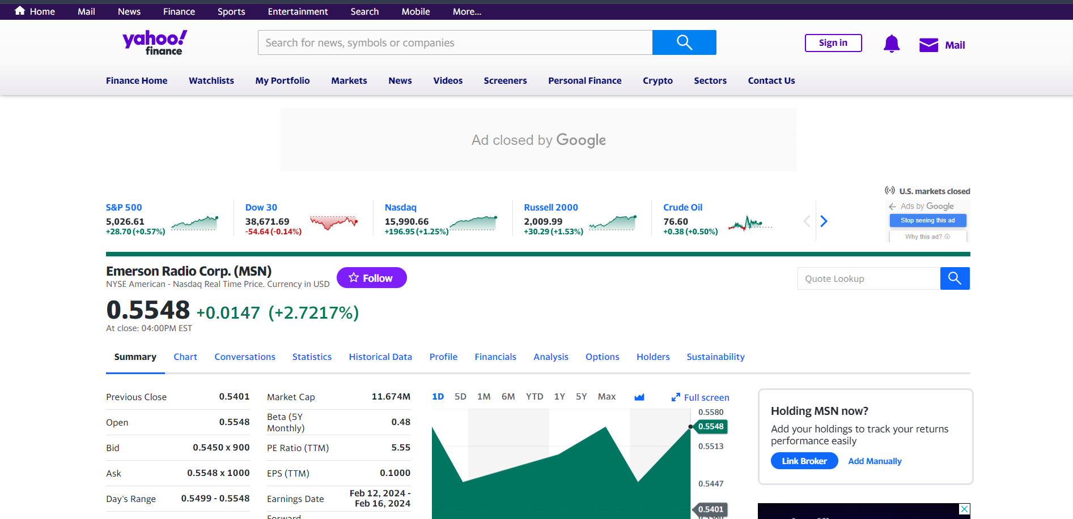

Figure 1 Interface of Yahoo Finance

# **PREPROCESSING**

Preprocessing is an essential stage in preparing raw data for detailed analysis, which is particularly important for forecasting the stock market. Preprocessing addresses issues such as missing information and inconsistent pricing scales by transforming past financial data into a more precise and organized format. Additionally, it adds calculated features to the mix, including moving averages, to give a more comprehensive picture. This careful planning guarantees that the data I feed into my model for my project—which involves making a stock prediction chart—is comprehensible, useful, and unambiguous. Because of this, it not only makes fundamental stock market patterns more understandable but also improves my model's capacity to forecast future movements by taking advantage of the complex interactions between different market indicators.

Figure 2 Install yfinance

The Python client library for Yahoo API, which is frequently utilized to retrieve data from Yahoo Finance, provides several advantages to developers and analysts that are involved in financial application development. Among these advantages are:

1. **Simplicity of Use**: By abstracting the difficulties of directly interacting with the Yahoo Finance API, the Python client library offers a simpler and more natural method of retrieving financial data. With a few easy function calls, users may access historical data, stock quotations, and other financial measures.

2. **Effective Data Retrieval**: The library makes it possible for users to get data quickly and effectively, giving them access to market data, financial reports, and stock information from the past and present. This is essential for timely analysis and decision-making.

3. **Extensive Financial Information:** A vast array of financial information is available to users, encompassing stock prices, market capitalization, dividends, earnings, and further information. This extensive dataset facilitates a wide range of financial analyses, from simple stock tracking to intricate investment plans.

4. **Data Analysis Library Integration:** The library works smoothly with prominent Python libraries for scientific computing and data analysis, including Pandas, NumPy, and Matplotlib. Within the Python ecosystem, this connection makes sophisticated data processing, analysis, and visualization easier.

5. **Cost-Effectiveness:** Using the Python client library to access Yahoo Finance data may be affordable, particularly for lone engineers, academics, and small teams. It gives users access to a multitude of financial data without requiring pricey financial data service subscriptions.

# **MODEL SELECTION AND DEVELOPMENT**

**STOCK PREDICTION USING LINEAR REGRESSION**

Using linear regression to predict stock prices allows machine learning to interpret financial market patterns. This approach uses linear regression to establish a direct link between past stock prices (input variables) and future prices (output variable) to simulate this relationship. It assumes that historical stock data, such as volumes and prices, can linearly predict future values. The method uses the slope and intercept of the best-fitting line to anticipate changes in stock prices while minimizing prediction errors. Although the simplicity of linear regression provides a straightforward starting point for financial research, the intricate world of the stock market may not always support linear regression's premise of linearity. However, it offers fundamental knowledge that opens the door to more complex prediction models and advances comprehension of market dynamics.

Figure 3 Linear stock prediction code

Figure 4 store prices input code

**STOCK PREDICTION USING ARIMA MODEL**

A fundamental tool in time series analysis, especially for forecasting, is the ARIMA model. Its purpose is to explain and forecast future points in a series based on the autoregressive component, which is the series' own historical values; the integrated part, which is the difference between values; and a moving average model, which captures shocks or random error factors. A time series is essentially modelled by ARIMA as a mix of its historical values and historical errors.

The regression of the time series against its own prior values is indicated by the letter "AR" in this sentence. The "I" denotes that the data values have been substituted—and this substituting may have happened more than once—with the difference between their values and the prior values. In the "MA" section, the error term is modelled as a sum of previous mistakes. To use the ARIMA model practically, charting the time series and analyzing its characteristics would be the first step. Autocorrelation and partial autocorrelation plots would then be used to determine the right parameters (p, d, and q).   
These parameters correspond to the number of lags in the prediction error, the number of lags in the autoregressive term, and the number of times the series needs to be different to reach stationarity. The model may be used to predict future values once it has been fitted and calibrated. Plotting both historical and expected values on a time series graph allows one to graphically express the model's effectiveness by assessing how closely the forecasts match the actual data.

**Explanation of using linear regression above this code in Googlecolab.**

Using historical data from the Alpha Vantage API, this Python script shows how to use linear regression to forecast stock prices. With each component carrying out a particular task in the entire process of data collection, preprocessing, model training, prediction, and visualization, the script is divided into clear sections.

1. **Data Retrieval:** The `get stock data` method retrieves stock data from Alpha Vantage daily for a given symbol, date range, and API key. To retrieve the time series data, it builds an API request and parses the JSON response.

2. **User Inputs:** The script asks the user to provide an Alpha Vantage API key, the start and end dates of the data retrieval period, and the stock symbol (for example, "AAPL" for Apple Inc.).

3. **Data Processing:** The dates, starting prices, and closing prices are extracted from the downloaded time series data by the script iterating over it. To make handling and visualization of dates easier, they are turned into {datetime} objects.

4. **Data Splitting:** The data is separated into training and testing sets using `train test split} from `sklearn.model selection}. This is a critical step in assessing the model's performance with unknown data.

5. **Model Training:** Using the opening prices as independent variables (features) and the closing prices as dependent variables (targets), a `LinearRegression} model from `sklearn.linear_model} is created and trained.

6. **Prediction and Evaluation:** The test set's closing prices are forecast using the trained model. The accuracy and goodness of fit of the model are assessed through the use of the mean squared error (MSE) and R-squared metrics obtained from `sklearn. metrics}.

**Data Visualization**

A line plot of the anticipated prices is superimposed on top of a scatter plot of the actual closing prices versus the dates, which is made using matplotlib.pyplot. This graphical depiction aids in evaluating the forecasting power of the model and comprehending the price pattern of the stock.

**The output of using the sklearn linear model in linear regression**

Figure 5 Stock prediction using linear regression for msn

Figure 6 Stock prediction using linear regression for AAPL

The model's accuracy in capturing actual market movements is demonstrated by the regression line's adherence to the actual data points, which are shown as blue dots. Regression line and these points should be tightly correlated to indicate accurate predictions; gaps should be visible to show differences between the predicted and actual values. The theme of the chart is established by its title, "Stock Price Prediction Using Linear Regression," and its clearly labelled axes for "Date" and "Closing Price" shed light on the financial metrics and temporal development that are being examined. To improve interpretability, the caption makes a clear distinction between the red prediction regression line and the observed data (blue dots). Gridlines make the graph easier to read and allow for a more in-depth examination of how well the model matches actual market movements.

# **SYSTEM DESIGN AND USER INTERFACE**

**Explain front-end development**

The Stock Price Prediction Dashboard is crafted using HTML, CSS, JavaScript, Ajax, and Scatter, offering an intuitive platform for visualizing financial data. When a stock symbol is entered, a backend request is sent to Alpha Vantage for historical data. This data is then examined using a Linear Regression model to predict future values. The user interface, which is characterized by its beauty and simplicity, includes interactive components such as data input forms and a submission button. All of this culminates in a dynamic graphical display of past and anticipated stock values, driven by Chart.js. This elegant combination of backend logic and front-end design guarantees a seamless user experience, giving investors insightful information about stock market patterns and supporting them in their decision-making.

Figure 7 Login page code

First, I want a user login for my system, so I create it in html language. This HTML code describes a two-pronged authentication system for a website, dividing user interactions into separate "sign-up" and "sign-in" portions that are contained in a single "container." In the sign-up area, new users may join using Facebook, Google Plus, and LinkedIn, or they can register by filling out specific boxes with their name, email address, and password, which will result in a ' Sign Up' button. On the other hand, the sign-in area serves current users by providing comparable social media login choices in addition to standard username and password fields, along with an extra link for password recovery. An 'overlay-container' is mentioned, which probably functions as a dynamic element to switch between the sign-in and sign-up views. This would improve the user experience by switching between different authentication types smoothly.

**Applying CSS in Login page.**

Figure 8 CSS code in login page

The title (h1) is given prominence through bold styling, drawing attention to key headings. To improve user comprehension, paragraphs, and span components are formatted for clarity and readability. Both usefulness and aesthetics are taken into consideration when designing links and buttons. To give visual feedback on interaction, buttons have rounded edges, a prominent colour , and a seamless transition effect. The login division (#login_div) is intended to serve as the central location for user authentication, guaranteeing a simple and easy login process. With a simple backdrop and borderless layout to reduce distractions, input fields are designed with the user's simplicity of use in mind. The dashboard's main structure is defined by the. Container class, which also adds rounded edges and a shadow effect to give the design depth and attention. Together with the form-container classes.

**Using JavaScript with chart.js in stock page creation**

Figure 9 using script and chart.js

A Stock Price Prediction interface is presented in this HTML document that has been modified with JavaScript and CSS. TensorFlow.js and Chart.js are integrated for possible machine learning applications and data visualization, respectively. A navigation bar provides quick access to areas such as Home, Compare, and Logout on the Bootstrap-styled (**async function**) interface. Users may choose a stock symbol from a dropdown menu, which launches a JavaScript function that makes asynchronous calls to the Polygon API to retrieve historical stock data. An interactive scatter plot chart provides a visual representation of the data, including opening and closing prices. The script uses jQuery to handle events and manipulate the DOM, which makes the user interface more responsive.

**Using JavaScript fetch function in stock chart-making**

The JavaScript Fetch method is essential for asynchronously downloading real-time market data from APIs without the need for page refreshes for creating stock charts. This makes it possible for charts to be dynamically updated with the most recent market data, guaranteeing that users receive stock trends and analyses as soon as possible within their online apps, increasing user engagement and interaction.

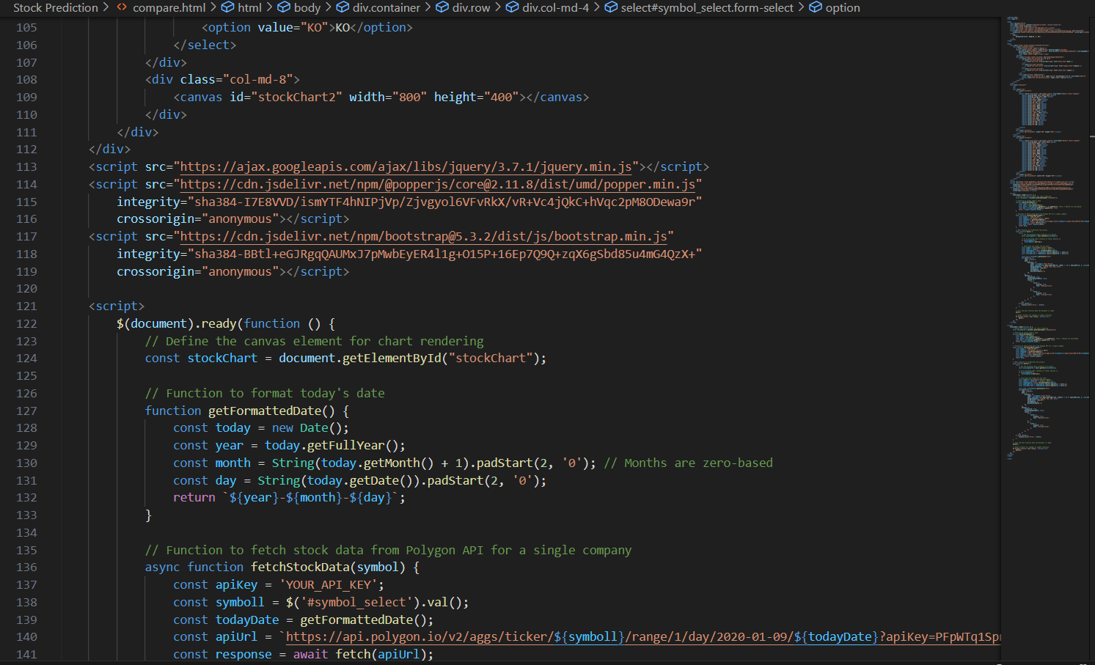

Figure 10 JavaScript using in stock prediction chart

**Using async function in stock chart-making**

Figure 11 using async function in stock charts making

When making stock charts, asynchronous functions are essential to having a fluid and responsive user interface (UI), especially when working with real-time financial data. When it comes to web development, async functions let your application start data fetching activities without stopping the execution of later code. This means that even when stock data is being fetched from external sources, the user interface may keep updating and responding to user inputs. The browser is not forced to wait for tasks to finish that use asynchronous data retrieval, such as getting stock prices or historical market data to display charts. Alternatively, it can perform various functions, such as managing user inputs or producing animations, guaranteeing that the program stays interactive and fluid. As soon as the stock data is obtained, async functions manage the response by processing and integrating the data into your charts using promises or async/await syntax. This might entail adding fresh data points to the chart, recalculating the indicators, or redrawing the chart to reflect the most recent state of the market.

**Using the fetch function in stock chart creation**

Figure 12 Fetch data

The fetchStockData method uses Chart.js to create a line chart that shows historical stock prices for a specified symbol, such as "AAPL" or "MSFT," that are retrieved from the Alphavantage API. It accepts two arguments: the ID of a canvas element and the stock symbol. After creating an API request with these parameters and an API key, the function uses `fetch` to get the data. It plots the line chart on the designated canvas, with dates on the x-axis and prices on the y-axis, after parsing the dates and closing prices. The layout of the chart is altered to improve readability and aesthetics. Errors are detected and recorded in the console for troubleshooting if they arise.

**Results of making stock prediction chart**

**User Login page**

Figure 13 User Login Page

My login graphic shows a contemporary, minimalistic login and sign-up interface. A prominent call-to-action encouraging new users to sign up and read predictions is located on the right side, while a login form with fields for a username and password is located on the left.

Figure 14 Login Error

Users are usually alerted with an error message when they attempt to log in using the incorrect password. This message lets them know that their attempt to log in was failed and asks them to try again using the proper password or change their password if necessary.

**Stock page**

**This stock page shows “AAPL” APIs shows stock prediction for one year.It include opening prices and closing prices.**

Figure 15 AAPL stock chart

The picture displays an AAPL (Apple Inc.) stock price scatter plot chart on a web interface. The top navigation bar has choices like "Home," "Compare," and "Logout," indicating that consumers may utilize this capability to explore the platform and contrast other equities. The scatter plot itself shows that the opening and closing prices of the stock of AAPL have a positive association. With the opening price on the x-axis and the closing price on the y-axis, each point on the graph represents a distinct instance of the stock's performance on a particular day. The plot's upward trend suggests that, typically, closing prices rise in tandem with opening prices, suggesting a steady growth pattern across the data's time span.

Figure 16 APIs dropdown selection

Figure 17 stock prices analyze

The graphic depicts a web interface with a scatter plot of the stock prices of Apple Inc. (AAPL). The data points are shown along an ascending line from left to right, indicating a high positive correlation between the opening, and closing values of the stock. The plot highlights a few distinct price points that represent individual occasions when the stock started and closed at certain levels. The fact that the data points are closely packed around the trend line indicates that the stock price has followed a steady pattern over the period the data covers. Traders and investors may possibly make better judgments by using this type of visualization, which makes it easy for them to understand a stock's past performance.

**Comparison of two Google finance-based APIs . First “AAPL” search and then search DIS .it is one year stock prediction in this country.**

Figure 18 Different APIs Select in dropdown

The opening stock values are depicted in the scatter plots for Walt Disney Co. (DIS) and Apple Inc. (AAPL), both of which have rising tendencies. A compact, regular cluster of data points on the AAPL plot hints to a significant, continuous increase in starting prices. The DIS plot, on the other hand, displays a more scattered group of dots, indicating greater volatility and a less steady but still upward trend in opening prices. This could reflect various market trends or company-specific elements influencing the development and stability of any stock. The picture shows scatter plots for Apple Inc.'s and Amazon.com Inc.'s opening stock prices, AMZN and AAPL, respectively. The robust positive trend seen in both charts suggests that the closing price typically rises in tandem with the starting price.

The closely clustered data points for AAPL attest to a regular and robust relationship between opening and closing prices. Even while AMZN's plot is likewise trending upward, the points are more dispersed, suggesting that the link between starting and closing prices is more variable. This fluctuation may indicate a more erratic stock or just a greater variety of trading styles. Growth within the period shown in the data is shown by both trends. Two scatter plots that purport to compare the opening prices of Apple Inc. (AAPL) and Amazon.com, Inc. (AMZN) stock prices are displayed in the image I have supplied. Plotting one variable along the x- and y-axes, scatter plots show individual records from the dataset as points; in this example, the opening price at two separate times or under two distinct situations is probably the variable being shown.

Figure 19 Two APIs comparison

Since the scatter plots themselves most likely show a link between opening and closing prices over an ambiguous period, they do not directly convey information regarding stock maintenance over a year. However, the AAPL stock would be seen as exhibiting good maintenance if we interpret "good stock maintenance" to indicate stability and predictability in stock prices. This is predicated on the data points' closer grouping on the scatter plot, which signals less volatility and more consistent performance.

On the other hand, the AMZN scatter plot shows more fluctuation in the changes in stock price between opening and closing periods due to its more widely distributed data points. This can be seen as less "maintenance" in that the stock fluctuates more, which would not be appealing to stability-seeking investors. In actuality, assessing "good stock maintenance" would need other information, including the stock's reaction to market developments, the year-over-year return, dividend payments, and the evolution of the company's financial situation and competitive position. Scatter plots show a correlation in a snapshot, but they don't give a whole picture of a stock's upkeep or performance over time.

# **Data Visualization**

To facilitate comprehensible data representation, a data visualization technique is necessary for the development of the Intelligent Stock Trader (IST) platform. This includes displaying historical stock performance patterns in connection to different data points, such as opening, closing, high, and low prices, utilizing graphs and charts. To facilitate decision-making, the visualization should let users enter intervals, profit margins, or stocks of interest. The dashboard of the system should be aesthetically pleasing and dependable, offering real-time data visualization that instantly updates to reflect modifications to data inputs. To highlight the advanced capabilities of the system, the data used for visualization has to originate from a substantial data source, such as a stock market platform, and it should be able to display complex connections within the data.

To handle and show the data efficiently, this calls for a mix of machine learning techniques and front-end programming expertise.

# **DATA QUALITY CHECK**

Ensuring data quality is paramount in the development of a stock prediction system, permeating every stage from data collection and preprocessing to model evaluation. Having high-quality data is essential to producing forecasts that are trustworthy and accurate. This calls for a diversified strategy.

**Accuracy and Consistency**: To make sure that the information is accurate and presented consistently, the data must be checked for these two qualities. This stage is essential to preventing mistakes from spreading across the system and seriously distorting forecasts.

**Handling Missing or Null Values:** Depending on the circumstances and the possible impact on the integrity of the dataset, missing or null values should be handled appropriately. These values are frequently found in real-world datasets and can be filled in using available data through imputation or by removing incomplete records.

**Timeliness and Representativeness:** The information must be up to date and accurate in reflecting both the history and current state of the market. This is necessary, given the dynamic and constantly shifting nature of financial markets, so that the system can learn from previous patterns and correctly predict future moves.

**Reliability and Bias Prevention:** The data must come from trustworthy sources, and the techniques used to obtain the data should be made to reduce biases. Predictions that are distorted due to biased data may favour some outcomes over others without any real basis.

# **INSTALL REQUIRED LIBRARIES**

Installing Matplotlib and Yfinance to the package of libraries improves the modeling capabilities for stock prediction. A Python charting toolkit called Matplotlib makes it possible to create static, interactive, and animated visualizations—all of which are essential for data exploration and results presentation. On the other hand, yfinance provides quick access to historical market data and is particularly made for downloading and manipulating financial data. With these features, one can easily access financial information, visualize results, and model and anticipate stock patterns using Pandas, NumPy, and Sk-learn, offering a full toolset for financial research and predictive modeling.

# **APPLICATION OF MACHINE LEARNING PRINCIPLES**

The creation of the Intelligent Stock Trader (IST) platform demonstrated how machine learning concepts might be applied effectively, with a focus on the importance of feature engineering, data preparation, and model selection. To guarantee data quality and consistency—a need for trustworthy model predictions—cleaning, normalization, and encoding were necessary first steps in the data preparation process. Feature engineering optimized the input for machine learning models by extracting and generating significant variables from the raw data, thereby augmenting the system's predictive power.

In order to make sure the models used were appropriate for the complexities of stock price prediction, much care was given in the selection and training of the models. Different techniques, from straightforward linear regressions to intricate neural networks, were assessed for their predicted accuracy and efficiency. Strict validation methods, such as cross-validation, were used to test the models against hypothetical data to guarantee their dependability and resilience.

Furthermore, a responsive architecture that could dynamically update forecasts with fresh market information was required because the system was built to handle real-time data. The platform's usability was greatly improved with the addition of a decision-making assistance component and an intuitive interface, which allowed users to make well-informed investment decisions based on complex, data-driven insights. The project's accomplishment in connecting theoretical knowledge with real-world financial technology solutions is shown by its comprehensive implementation of machine learning techniques, from data management to user interface.

**Forecast for the Stock**

**Time Series Analysis:** To spot patterns and trends over time, machine learning algorithms can examine past stock market data, including price movements, trade volumes, and macroeconomic variables. Recurrent neural networks (RNNs) and autoregressive integrated moving average (ARIMA) models are two time series analytic approaches that may be used to predict future stock values based on historical performance.

**Feature engineering:** A range of input features, such as technical indicators (like moving averages, relative strength index), fundamental data (like earnings reports, balance sheets), and market sentiment indicators (like news sentiment, social media activity), are frequently used by machine learning models for stock prediction. To enhance the model's prediction capabilities, feature engineering entails choosing and modifying pertinent characteristics.

**Sentiment analysis:** News articles, social media messages, and other textual data about stocks and companies may be analyzed using Natural Language Processing (NLP) approaches. The general sentiment (positive, negative, or neutral) reflected in various sources may be evaluated by sentiment analysis algorithms, which then use this data as an input feature in stock prediction models. While negative sentiment may portend future downturns, positive sentiment may reflect an optimistic view of the market.

**Ensemble Methods:** To increase prediction accuracy, several separate models can be combined using ensemble learning techniques like random forests or gradient boosting machines. When it comes to stock prediction, ensemble techniques can produce more accurate and consistent forecasts by utilizing a variety of algorithms and input characteristics.

**Risk management:** When it comes to stock trading, machine learning algorithms may also be utilized for risk management. Models may evaluate the possible risks connected to various portfolios or investment strategies and assist investors in making better selections to reduce negative risk. To determine the likelihood of severe market occurrences, methods like value-at-risk (VaR) analysis and Monte Carlo simulations may be used.

# **EVALUATION AND RESULTS**

The efficacy and precision of the machine learning models in forecasting stock prices were the main subjects of the Intelligent Stock Trader (IST) platform's examination and findings. To calculate the system's prediction accuracy %, real-world data was compared to the system's predictions during the assessment phase. For example, the actual market data of the next day was compared with the system's forecast from the previous day, and similar comparisons were done for weekly and monthly projections. This method offered a quantifiable indicator of the prediction accuracy and dependability of the system.

The outcomes were probably examined using a variety of measures, which are common in machine learning model evaluations, including accuracy and precision. The system's capacity to manage data in real-time and help with decision-making through 'What-If' my task was another essential component of the assessment. This assessed the platform's practical usefulness for assisting end users in making wise investment decisions in addition to its technological stability.

As a result of the review, the strengths and limitations of the models that were put into use would have been brought to light, providing information about areas that may be improved—such as feature engineering, model tweaking, or even investigating different machine learning techniques. The critical analysis and findings would greatly advance knowledge of the real-world effects of using machine learning concepts in the field of financial technology, especially in the dynamic and intricate area of stock trading.

# **CHALLENGES AND SOLUTIONS**

While I develop this system some machine learning offers immense potential, it also comes with its own set of challenges:

**Data Quality:** Poor data quality can lead to inaccurate models. Solutions include data preprocessing techniques, data cleaning, and feature engineering.

**Bias and Fairness:** Machine learning models can perpetuate biases present in the training data. Mitigation strategies involve careful dataset selection, algorithmic fairness techniques, and regular model audits.

**Interpretability:** Black-box models can be difficult to interpret, leading to a lack of trust. Techniques such as model-agnostic interpretability methods and transparent model architectures address this issue.

**Scalability:** As datasets grow larger, scalability becomes a challenge. Distributed computing frameworks and efficient algorithms help in scaling machine learning systems.

**Privacy and Security:** Protecting sensitive data is crucial. Privacy-preserving techniques like differential privacy and secure multi-party computation safeguard data while allowing meaningful analysis.

**Data Gathering and Utilization:** Acquiring a sizable volume of high-quality data that corresponds to the desired forecast. To illustrate the sophistication of your system, this entails selecting data from many stock exchanges and making sure it covers a variety of firms or securities with detailed pricing data.

**Choosing appropriate machine learning models or algorithms** for the software application falls under the category of software and algorithm selection. Making this choice will have a significant impact on how well your stock forecasts perform. A dependable dashboard for data visualization must also be incorporated into the system, which presents significant hurdles in front-end development and user interface design.

**Physical Difficulties**

Infrastructure Scalability: Increasing server capacity, streamlining data storage, and guaranteeing system resilience are some ways to ensure that the physical infrastructure can withstand the amount of data and the computing needs of real-time analysis.

Overcoming hardware-related constraints is necessary to process and store data, particularly when working with huge datasets and intricate computational models that may call for high-performance computing solutions.

Network delay: Resolving network-related problems that may impede the timely processing and distribution of real-time data may need the adoption of quicker technologies and protocols in the network to minimize delay.

bodily Security: ensuring the computers and other equipment that house the stock prediction system are physically secure, guard against unauthorized access, and reducing the possibility of bodily harm or sabotage.

**Solutions for these challenges**

**Processing Data in Real Time:**

Use technologies such as Apache Spark for real-time data processing and Apache Kafka for real-time data streaming to create effective data processing pipelines.

Utilize in-memory data processing to lower latency and boost system responsiveness.

**Combining Various Data Systems:**

Make use of middleware and APIs to make integrating various systems and data sources easier.

Use a microservices design to provide easy maintenance and smooth communication between the system's many components.

**System of Decision Support:**

Create a modular framework that allows various machine learning models to be put in and assessed based on how well they help decision-making.

'What-If' analysis results and data may be visualized using interactive dashboards created using Tableau or Power BI, which improves decision assistance.

# **ETHICAL AND RULES**

Ethical considerations are paramount in the application of machine learning. Some key ethical principles include:

**Transparency:** Machine learning processes should be transparent, and stakeholders should understand how decisions are made.

**Fairness:** Models should be fair and unbiased, treating all individuals equally regardless of race, gender, or other protected attributes.

**Privacy:** Data privacy should be respected, and personal information should be handled responsibly to prevent misuse.

**Accountability:** Individuals and organizations should be accountable for the outcomes of machine learning systems.

**Compliance:** Adherence to relevant regulations and guidelines, such as GDPR in Europe or HIPAA in healthcare, is essential.

# **APPENDICES**

This section functions as an appendix to the main report in compliance with the rules supplied. It presents supplementary resources that enhance understanding of the project's operational aspects, development process, and complexity. A wide range of materials are included in the appendices, including thorough development process instructions, schematic diagrams of the system's structure, visual representations, and an extensive bibliography. These supplemental materials are intended to provide a more thorough understanding of the project's framework by illuminating the approaches, tools, and theoretical foundations that went into developing the Intelligent Stock Trader platform.

My GitHub Repository path : <https://github.com/MATHU0712/stock.git>

My google drive link : It has my full ML project files

https://drive.google.com/drive/u/0/folders/1kAnXq2dFG_QqkRL4HQDgG8EQziXqzXJ3

**system architecture diagram**

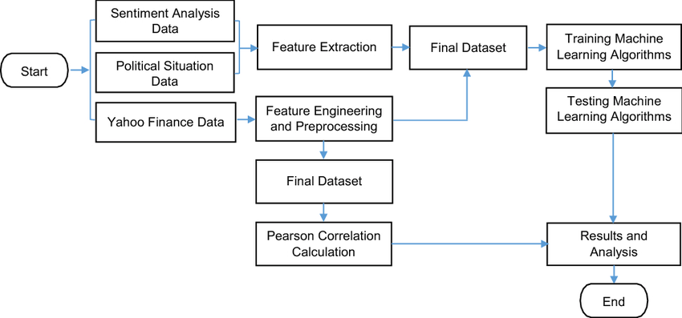

Figure 20 System architecture diagram

# **SELECTING FRAMEWORK FOR BACKEND DEVELOPMENT IN JAVASCRIPT AJAX.**

Choosing a JavaScript AJAX framework for backend development offers multiple appealing benefits. First, it facilitates consistency and streamlines the development process by enabling developers to work with a single language throughout the whole stack. These frameworks—like Node.js—are well-known for supporting asynchronous operations, which make it possible for I/O to happen without blocking and improve the speed and responsiveness of online applications.

Additionally, JavaScript AJAX frameworks are perfect for managing high traffic levels since they are built with scalability in mind. They use concurrent connections and event-driven architecture. Furthermore, these frameworks' vast ecosystems and vibrant developer communities offer a multitude of resources, libraries, and third-party tools that make development and maintenance easier. Using frontend development expertise for backend tasks also expedites development and lowers the learning curve for developers. Lastly, real-time communication is supported by a large number of JavaScript AJAX frameworks, which makes it possible to create interactive and cooperative apps. Together, these characteristics make JavaScript AJAX frameworks a well-liked option for creating contemporary online applications that prioritize developer productivity, scalability, and efficiency.

# **CONCLUSION**

In conclusion, the stock prediction chart system stands as a remarkable illustration of how machine learning can be harnessed to shed light on the complexities of financial markets. The system offers a sophisticated stock price forecast by fusing innovative algorithms with historical stock data, making it an invaluable resource for financial experts and investors. The dynamic charts are interactive canvases that show underlying market patterns and possible investment possibilities in addition to being useful as visual aids. This system provides a complex yet user-friendly platform that helps users make educated decisions, demonstrating the synergy between technology and finance.

This project effectively utilizes Python's machine learning capabilities to forecast stock values, connecting the Yahoo Finance API to source data. Through the combination of a frontend built with HTML, CSS, and JavaScript and Scatter for the chart and Ajax framework, an interactive dashboard is created that improves user interaction. Fundamentally, the project uses the sklearn library's Linear Regression to process historical stock data and divide it into training and testing sets. This helps the model learn and makes it possible to estimate stock closing prices with accuracy. By providing context for the actual vs expected numbers and illuminating emerging market patterns, the dynamic chart display of these forecasts enhances the user's analytical viewpoint. This project serves as an example of machine learning and finance.

The dynamic chart is the central component of this program. It is an essential element that combines real closing prices with their predicted equivalents to provide a dynamic representation of market dynamics. This chart does more than just fulfill its fundamental purpose; it provides a window into the financial market's rhythms and highlights patterns that the unaided eye could miss. This project goes beyond simple coding to demonstrate the revolutionary potential of innovation by fusing actual financial data with machine learning and demonstrating the coherence between both domains.

# **REFERENCES**

finance.yahoo.com. (n.d.). *Emerson Radio Corp. (MSN) Stock Price, News, Quote & History - Yahoo Finance*. [online] Available at: https://finance.yahoo.com/quote/MSN?p=MSN&.tsrc=fin-srch [Accessed 9 Feb. 2024].

‌ colab.research.google.com. (n.d.). *Google Colaboratory*. [online] Available at: https://colab.research.google.com/drive/1uZA3_sb8_94LzWMnYlQe508p1RuDhrUq?pli=1#scrollTo=KKIigT9lFs42 [Accessed 10 Feb. 2024].

www.learndatasci.com. (n.d.). *Python for Finance, Part I: Yahoo & Google Finance API, pandas, and matplotlib*. [online] Available at: https://www.learndatasci.com/tutorials/python-finance-part-yahoo-finance-api-pandas-matplotlib/.

# 